
Qwwdq

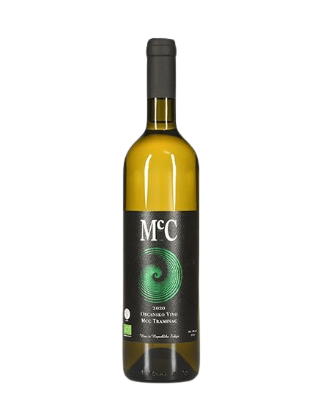
Traminac
- Dry white wine -

About the vine

Grape varieties:
- Traminac
Origin: Erdevik, Fruška Gora
Serving temperature:9-11 ºC

A varietal white wine, well-balanced with mildly pronounced acidity and a yellow-green color. It features expressive aromas of tropical fruit, peach, and spices.
Food pairings include mussels, eel, pizza, omelets, breaded turkey, soft cheeses with more pronounced aromas, and exotic cuisine.
We produce an average of around 4,000 bottles of Traminer per year. It is our most awarded and best-selling white wine.
Awards

2024 – The 2021 Traminer won a bronze medal at the Wine Vision by Open Balkan.
2023 – The 2021 Traminer won a gold medal at the Wine Vision by Open Balkan.
2015 – The 2012 vintage won a silver medal at the Gastro Fest.
2016 – The 2013 vintage won a bronze medal at the Decanter World Wine Awards.
2016 – The 2016 vintage was honored at the Ukus Fest as the best wine of the event.
2020 – The 2017 vintage won a bronze medal at the Saint Trifun Celebration.
2021 – The 2018 vintage won a silver medal at the Rivica Wine & Food Festival.
2022 – The 2019 Traminer won a bronze medal at the Wine Vision by Open Balkan.
2022 – The 2018 Traminer was included in the “Top 50 Wines of Fruška Gora.”
